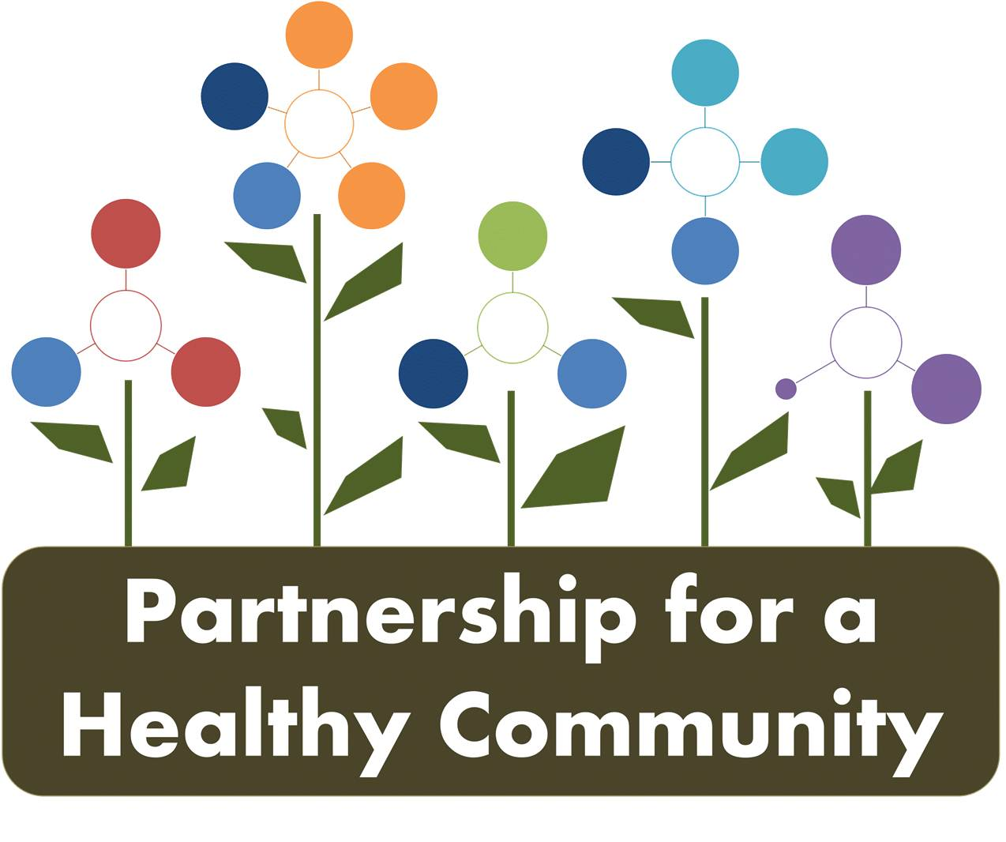
Lung Cancer Committee Meeting
April 11, 2018 1-230
Woodford County Health Department
Attendees: Evelyn Neavear, Diana Scott, Donna Long, Diane Hahn, Julie Angle, Melissa Goetze, Andrea Ingwersen
Call-in: Nathaniel (Nate) Johnson, Jessica Draper
The group began the meeting with introductions. Evelyn Neavear facilitated the meeting and the group reviewed the each intervention/task of the lung tobacco dashboard.
For progress reported on the dashboards, keep the creation date, and add updated date on the bottom left corner of the document. Ex: 2-18 is creation date, 4-11 is last update.

The group reviewed and updated the lung/tobacco dashboard by intervention. Discussion was as follows:
1. The group felt each action was already being done in healthcare settings and dentist offices. A universal tool would be extremely difficult to implement across healthcare systems and that universally, providers are asking patients about tobacco usage and giving them the tools/resources to quit. Perhaps need further discussion?
2.1. Nate reported current cessation programs he researched: OSF offers a free program for the public and employees; classes are 4 or 8 weeks in duration. OSF respiratory clinic staff follow up with participants month by month, depending on dependence, usage, etc.
-Unity Point offers a 7 week class/$150.
-OSF St. Joseph and McLean County Health Dept. partner to offer Freedom from Smoking.
-Hopedale Wellness Center has a smoking cessation program also. Nate will follow-up about program details.
Discussion ensued about PCCHD, TCHD & WCHD tobacco grants and how the structure of those grants worked, explaining different aspects of grants and the grant enhancements, how HD’s can decide which enhancement to work on based on their county. Each tobacco grantee must work on Smoke-Free Illinois Compliance and promoting the Quitline. Each county’s grant enhancements:
PCCHD (Hult)-Multi-unit housing
TCHD-Social Norms Campaigns
WCHD-Referral Partners
-moving forward, the tobacco grant coordinators will share information and perhaps meet separately to align grant goals through the Partnership and to be more effective since a lot of information/population is overlapping Re: providers or media outlets
-this group will continue to promote the Illinois Tobacco Quitline and smokefree.gov
2.2 & 2.3 Employee wellness programs and how to investigate if employees were given incentives to quit tobacco or smoking cessation classes are promoted/offered? Is there a “gold standard” of worksite wellness programs that the group can promote? Can we create a survey and gather data?
-Andrea told the group that Hillary Aggertt can give more insight into this as she has researched a worksite wellness program for Woodford County. Additionally, TCHD/Hult did some work around worksite wellness under the Community Transformation grant in 2014; major employers in the tri-county area were surveyed. (Ev will follow-up to find files, survey, etc at TCHD.
3., 3.1, 3.1a & 3.1b Julie Angel discussed TCHD’s social norms campaigns and how that will be rolled out to area media, benefitting all counties as media outlets are shared. Additionally, May 31st is “World No Tobacco Day” and the group will coordinate public awareness efforts through the 3 HD PIOs to increase reach of messaging.
-The Partnership has its own FB page that Sara Sparkman and Diana Scott are administrators of, any of the initiative groups can send things to them to post, to increase reach of public education/awareness efforts.
3.1c-Nate will follow-up to get baseline data
3.2 Baseline data on quit smoking attempts. Where did that baseline come from? BRFSS? Hillary perhaps can shed some light on that baseline and what questions are on BRFFS regarding smoking as that assessment will take place again soon.
4.0, 4.1 Discussion took place about how smoke free policies are enforced in each county and how new and existing establishments are educated via inspections, tobacco grants, etc. Education is being done, compliance of SFIA and follow-up is different depending on county and individual city/town, and local law enforcement, city council.
Andrea reported WCHD sent “friendly” reminders about SFIA compliance at the beginning of the year ( 10th anniversary of SFIA) to all food establishments (175), chambers, businesses, townships and municipalities (11), etc. and is posted on WCHD FB monthly through July 2018.
4.1 Julie Angle is creating a procedure for law enforcement for SFIA compliance, will be distributing to each police department. She will gladly share with the group.
Ev explained for the group’s knowledge that one TCHD health inspector has LC13 licensure, and see more SFIA violations than other health inspectors that only do food inspections. Diana reported that all PCCHD inspectors do both LC13 and food inspections.
4.1, 4.2, 4.3 Jessica reported about her tobacco grant enhancement of smoke-free multi-unit housing and that it will be an Illinois law that all HUD housing has to be smoke-free by July 1, 2018. Peoria HUD housing is managed out of Springfield so that can make things complicated.
Jessica worked with a large Peoria apartment complex pool to remove designated smoking area, pool is entirely smoke-free. She has also worked with Bradley and Midstate to become smoke free campus.
Andrea reported Eureka Student Life was an ITQL official referral partner and that student council has discussed making Eureka College a smoke-free campus.
Diana said PPD works with Reality (teens) portion of their tobacco grant and worked to have a park in Peoria smoke-free last year, one of the city’s water parks. This year the group is focusing on policy.
5. Julie Angel reported to the group about tobacco grant enhancement social norms campaign, which included stall readers and banners at all Tazewell County junior and senior highs. A multimedia campaign will be coming out soon.
5.1 &5.2 The group discussed that Illinois Youth survey will be baseline data for youth (30 day use) and 2018 was a survey year, data should be available in the fall.
Julie Angle reported all Tazewell schools that were eligible (6th, 8th, 10th and 12th) were registered and Andrea reported all but one (grade school) of Woodford County schools were registered, and all high schools. Follow-up will occur to make sure schools actually completed the survey successfully.
The ITQL is also a source of baseline data, as tobacco grantees get monthly reports but the platform is currently being updated, and grantees will have not gotten reports for several month.
My notes get a little fuzzy here, please fill in the blanks. 6.1, 6.2 PCCHD Reality group is working on policy and promoting Tobacco 21 from a youth perspective, and Peoria County promoted it at this year’s legislative breakfast. PCCHD Board of Health adopted?
Julie Angel reported that the city of Washington was in policy 2nd reading/review (it has since passed, yay!), and that new policy included e-cigarettes in public places. Pekin and East Peoria also interested.
The group discussed home rule vs. non-home rule communities/counties and how that impacts policy adaptation and promotion, which it was to important to keep in mind in the future.

**See revised lung cancer tobacco dashboard.
-May will start the 90-day implementation plan.
Additionally, the group discussed the creation of a document that each member can add to as work is completed, so everyone can keep track of progress between meetings. Evelyn will explore options and email the group for feedback.
The meeting ended with discussion regarding missing community partners to invite to participate, Evelyn will reach out to the following: American Lung Association, American Cancer Society, American Heart Association, Women Against Radon, Area Churches/Ministerial Alliances
The May meeting will focus on the lung cancer radon dashboard as Jim Emmanuel from IEMA will be in attendance.
Next meeting for Lung Cancer: May 9, 2018 from 130-3 at Peoria City/County County Health Department

