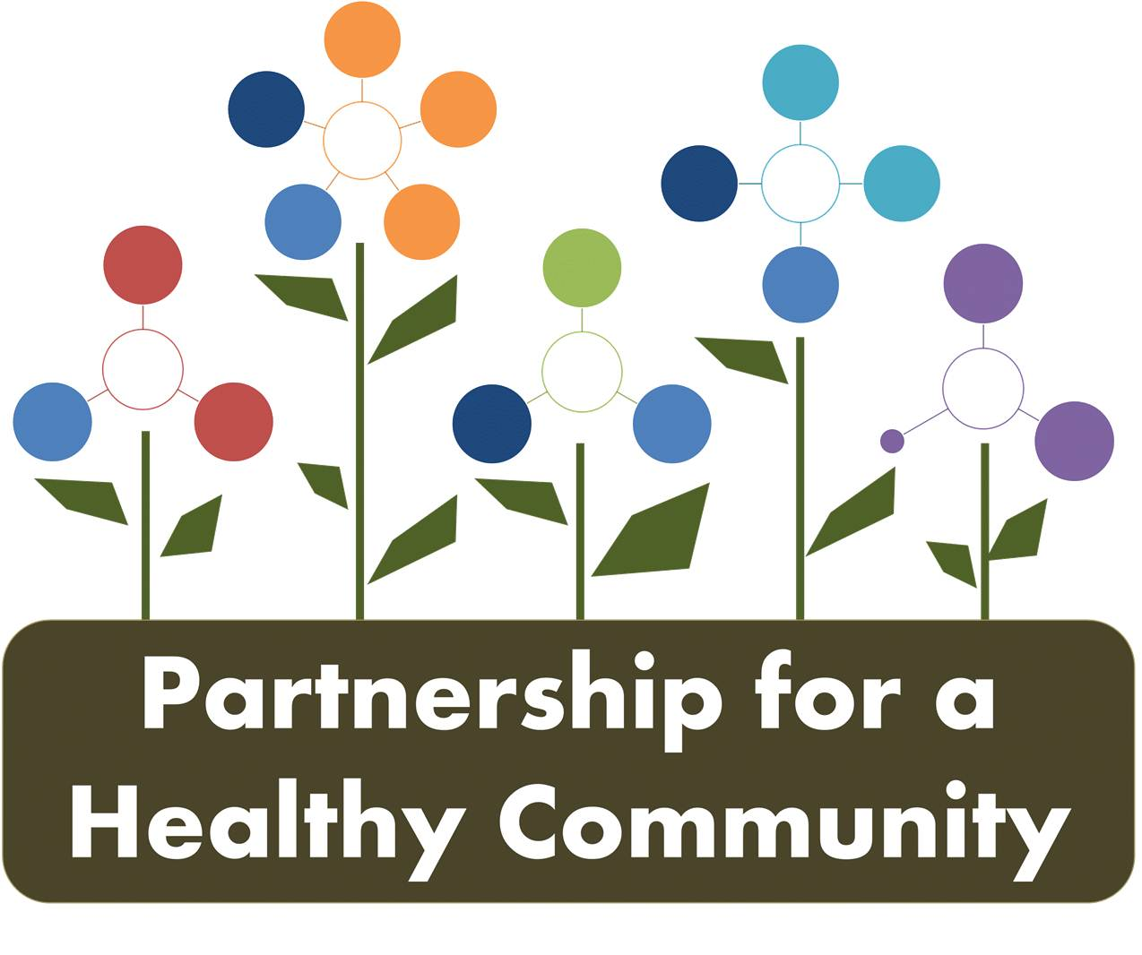
Breast and Lung Cancer Action Team-Quarterly Meeting
Tuesday March 19th, 2019 2:00-3:30 PM
Tazewell County Health Department
In Attendance:
Greg Eberle-Breast Cancer Action Team Chair, Hopedale Wellness Center/Medical Complex
Ev Neavear-Lung Cancer/Radon Action Team Co-Chair, Tazewell County Health Department
Julie Angle- Lung Cancer/Tobacco Action Team Co-Chair, Tazewell County Health Department

Hillary Aggertt-Woodford County Health Department
Jim Emanuels-Peoria Radon
Melissa Goetze-Tazewell County Health Department
Julie Herzog-Tazewell County Health Department
Andrea Ingwersen-Woodford County Health Department
Jessica Johnson-Hult Center for Health Living
Nathaniel Johnson-UnityPoint
Donna Long-UnityPoint
Nicole Robertson-Methodist College
Diana Scott, Peoria City/County Health Department
Michele Sharping-Tazewell County Health Department

P4HC Board updates and prioritization for 2020:

Greg reviewed the purpose of the Partnership for a Healthy Community website, www.healthyhoi.org and that P4HC board will be getting training on the website, how to update content.

-the board and action teams would like the website to be a more robust resource; have communication streamlined, include meeting minuets, events, and examples of group work

-need to do a better job of communicating between action teams, break down silos of action teams and priorities. The website is structured to keep everyone informed, it is currently not being updated regularly.

-ITFC grantees (Julie A., Andrea and Jessica) volunteered to update the lung cancer tobacco portion

Ev-opened discussion about who is in charge of approving content? The action teams don’t even approve minutes. Who approves meeting minutes? Are the minutes reviewed before posting?

-Do action teams approve? Board? Is there a staging area for content before it’s published?
-needs to go back to the board for further discussion before people feel comfortable volunteering to update website or be responsible for content.

Hillary reviewed results of the March priority meeting, starting in 2020, the priorities will be:

Mental Health
Obesity
Substance Abuse
Cancer-breast, lung (tobacco and radon), colorectal

-For prioritization, the Hanlon Method was used, reviewing data, areas of concern, etc. for size, seriousness and effectiveness.

-Need to create a separate meeting for data review and to create overarching goal for all 3 cancers

-Diane and Wendy CRC Life-agreed to chair colorectal cancer action team

-Group voted-all 3 cancers in 2020? Yes!

Ev-radon has to be part of tri-county partnership as she is writing a grant for next 3 years. All agreed yes. She has to utilize radon cation team for group work.

Lung Cancer/Tobacco:

Julie Angle-new co-chair of lung cancer/tobacco-gave ITFC Fy’19 grant overview and that Tobacco 21 is waiting for Gov. Pritzker to sign.

-Illinois Tobacco Free Communities grantees tagline is: “Tobacco Free where we live, work, and play.”

Julie Herzog-gave an update of AOK Network Smoking during pregnancy initiative, created infographics and will be hosting focus groups with TC WIC parents to get feedback.

-after focus groups, posters and social media campaign will be rolled out through Network and local media channels.

-Target population is 18 and older Tazewell County residents, but Peoria and Woodford residents will see as well as media outlets are the same.

-currently AOK Network is utilizing the TIPS campaign by CDC with AOK and TCHD logos, March-May 2019.

-will be creating strategic plan for FY20, the current initiative to reduce smoking during pregnancy will continue.

Tobacco Dashboards were quickly updated:

-Quitline information was distributed at Peoria home show
-JH has list of managed care organizations that provide smoking cessation services
-Jessica and Andrea-2 separate presentations to teens on vaping
-group work-participation in IYS needs to increase (not just registration)

Lung Cancer/Radon:

Ev reviewed amendment to TCHD’s current radon grant from IEMA and 90 day action plan:

-still need to create written resource guide of tri-county radon mitigators.
-purchase stands for outreach events
-kits for sustainability programs for HD’s (purchased?)

Next 3 year grant due 4/1, starts 10/1/2019:

Ev will send group goals and objectives to review, please give her feedback by Friday 3/22.

-New grant goals and tasks (proposed)-800# for radon questions? Tie into 211 somehow?
Current statewide 800# through IEMA is only manned by 2 people.

-get TCHD program assistant trained and increase knowledge to be a person people can call and get answers in timely fashion.

Jim-reviewed proposed radon tenant legislature and current laws; current law leaves out 1/3 of Illinois residents, renters.

-currently, rental properties do not have to disclose radon levels or even test. Legislation sponsored by Midwest ARST and Lung Association; tenant can get out of lease if high levels of radon and not mitigated within 120 days.

-Jim will send witness slips to group to complete when time comes.

Jim updated the group on some outreach activities for the dashboard:

-current administration wants to cut EPA budget, which includes Radon funding, Jim will be joining ARST in Washington DC to advocate for continued funding and promote radon testing/awareness.

-January, Radon Action Month-Midwest ARST awareness campaign, reached 57, 000.

-Peoria home show booth, in partnership with TCHD selling radon test kits-approximately 400 people reached; TCHD sold 108 kits.

-Presentations at Menards and Dunlap library; plans to attend Galesburg home show.

-Attended radon stakeholders meeting; approximately 190 people in attendance.

The group discussed latest data available of tags sold to mitigators, numbers are down in Central Illinois but for entire state. This may be due to a number of factors, lack of reporting to IEMA, IEMA not updating website, etc.

Breast Cancer:

Greg distributed the 2018 screening numbers to the group, data was compiled from all screening providers. The data tracks screenings overall and first time screeners.

-There was a 2% increase in screenings compared to 2017; screenings for age group 60-69 also increased.

-screening numbers will continue to be compiled to looks at trends, this “real-time” data is powerful and sends a strong message as group work continues. The ultimate goal is early detection and measure cancer rates across priorities.

-the BC Action Team needs to discuss how to distribute the positon statement now it has been

Gail discussed with the group Senate Bill 162; bill would require insurance to cover diagnostics. Screenings (mammograms) are 100% covered, more advanced diagnostics such as ultrasound, MRI are not necessarily covered 100%. Depends on individuals insurance coverage, could have high deductible or high co-pay. Komen and IBCCP can help with these barriers.

Michelle told the group that as of January 1, 2020, if IBCCP deems a patient “high-risk” at enrollment, an MRI will be automatically done.

Announcements:

Jim asked about a position statement. Could one be created to advocate for radon testing and mitigation to go along with supported legislator. The Lung Cancer radon Action Team could take that on as group work at the next meeting. Andrea will email Jim and Ev the BC position statement as an example to work from.

Donna informed the group about UnityPoint’s high risk cancer clinic. The clinic is covered by insurance, patients get automatic referral from PCP if found to be high risk of any cancer. The goal of the clinic is earlier intervention, with quicker diagnostics and treatment. The clinic is open on Tuesdays. Email Donna or see UnityPoint website for more information.

Nicole introduced herself to the action team, she is an instructor at Methodist College. The college received a 4 year federal grant to increase number of nurses focused don community based primary care. Nicole gave an overview of the programs goals, and that she will be attending meetings and working with her students for P4HC projects.

Next meetings:

***Special meeting to discuss 2020 prioritization and goals to include colorectal cancer-Monday, April 1st, 2019 1:00-3:00pm at Woodford County Health Department.***

Breast Cancer Action Team: Tuesday, April 9th, 2019 2:00-3:30pm at Peoria City/County Health Department

Lung Cancer Action Team: Thursday, April 11th, 2019 2:00-3:30 at Woodford County Health Department

