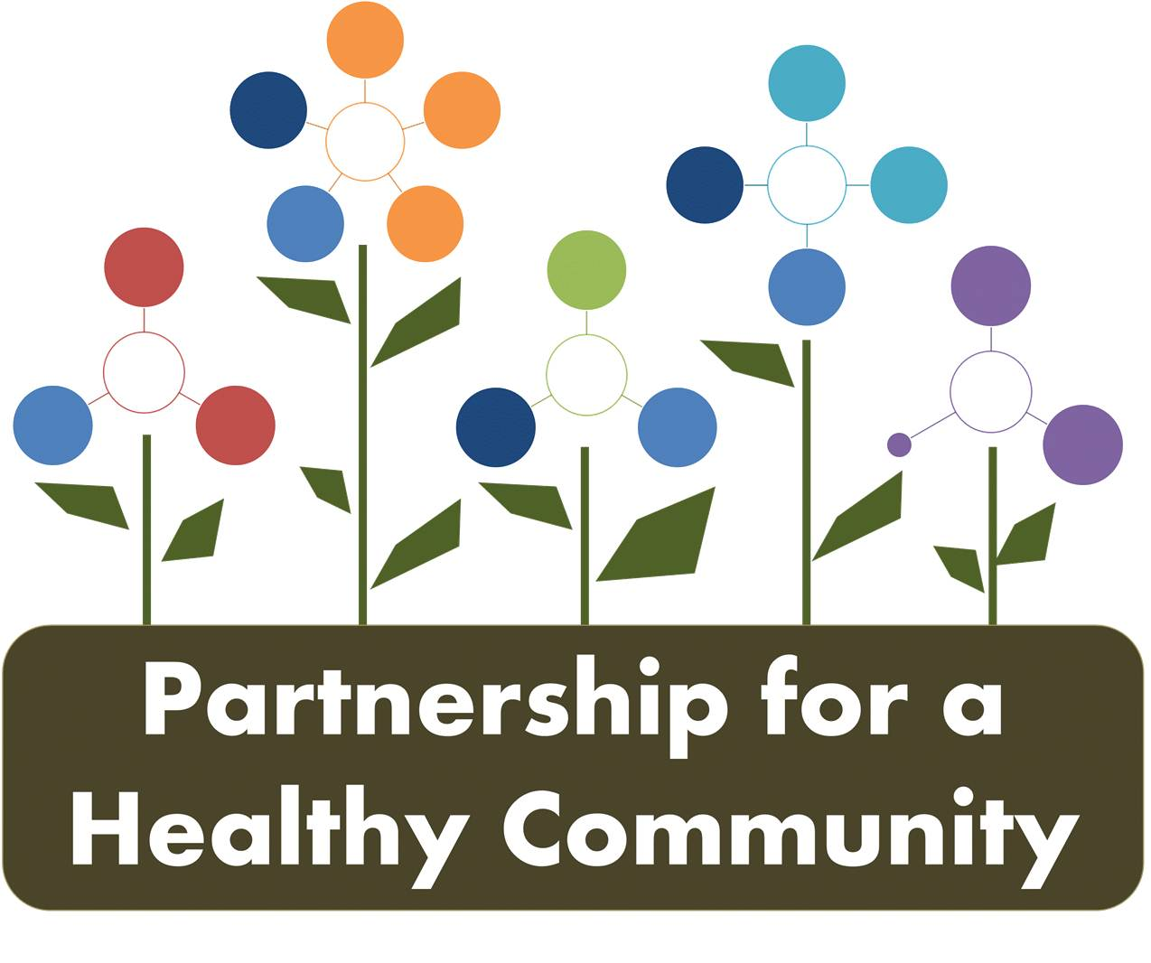
June 19, 2018
Attendees: Julie Angle, Jim Emanuels, Melissa Goetze, Michelle Hobbs, Andrea Ingwersen, Donna Long, Bre’Asia Peary, Diana Scott, Katie Traenkenschuh
The meeting was the quarterly meeting and was devoted to radon, tobacco and breast cancer. Greg and Ev not able to attend today, Andrea facilitating today.
Diana will be updating all dashboards after this meeting, look for date of at bottom of dashboard for updated version.
The group discussed the IDPH/Illinois Cancer Partnership Illinois Cancer Comprehensive Control Plan (see attached) and the IDPH Cancer in Illinois booklet.
The Center for Asian Health Equity/Hopelight Foundation has a small grant opportunity for LHD’s to provide FIT tests. Diana sent info to Hillary (WCHD) and Amy (TCHD) about this grant opportunity for colon cancer.
Jim Emanuels provided radon information at the last meeting and has now joined the group. He provided additional information on his business and explained his role in the Midwest Radon Reduction, and the representation for national radon initiatives.
Andrea reviewed the Partnership for a Healthy Community and how we arrived at our priorities. The work that has been completed by the breast and lung cancer groups in the past year is reflected in the dashboards. The dashboards are updated after our meetings.
Radon:
Tasks 1-1.3-The group discussed radon messaging, utilizing Healthy HOI FB page, websites and home show.
Jim reported to the group that he participated in the Peoria Menards Contractors Day, which is a 3-4 day event. A display board and education materials are distributed. The group discussed participating in this event in the future.
Melissa reported that TCHD is getting a new website. Radon will have a webpage that can be updated easily and include links to educational materials for medical professions, home owners, realtors, and to the Illinois Task Force. Resource guide will be included as well and can be utilized and promoted by this workgroup. The radon grants were reviewed, PCCHD does not have a grant, TCHD does.
Melissa reviewed information she received from IEMA and American Lung Association training regarding school radon testing. She discussed prompting schools to test for radon, of 70 schools that have tested since the new regulation required testing, 60% had high radon levels. The group discussed adding this to tasks and whether that would be realistic, what information about testing was available and perhaps creating resource to inform schools.
January 2019-Radon Action Month, joint messaging will be planned again in the fall. A reminder, utilizing the Healthy HOI FB page, and then sharing to individual agency FB pages can increase reach of messaging.
Tasks 2-2.4- Discussion on need to update number of kits sold or provided by HDs since IEMA website has not been updated, and possibly won’t be until next summer.
The Radon grant cycle was reviewed (starts 10/1/18) and a joint funding possibility was discussed. The 3 HD administrators and Partnership board would have to discuss.
Diana reported that PCCHD Healthy Homes and the HUD Lead poisoning grant is scheduled to end soon. If funding is pursued in the future, PCCHD will try to get radon mitigation for low-income included.
Jim stated that the numbers for mitigation are available from IEMA even if website is not updated, per zip code, per city etc. and he would get those to the group. All mitigators have to report to the state by January for the previous year, mandatory to report. He will get the numbers and email to Hillary.
Tobacco: For FY’19, ITFC(the IDPH tobacco-free grant) is offering a regional grant. Peoria, Tazewell and Woodford are discussing writing for the FY’19 grant regionally, will receive more money and already working together, media outlets, are the same.
While waiting for the new grant guidelines, the group continues to promote the Quitline. The group discussed how that data is reported to the HD’s and how that may not accurately reflect all the promotion of the Quitline. Moving forward the group can keep track on the dashboard of Quitline promotions regionally.
Tobacco 21 is waiting for Governor’s signature, passed the House and Senate.
*Jessica’s emailed update: Worked with PHA to let residents know that all Housing Authorities will be smoke and vapor free by July 31st.
-Still working with Bradley and Robert Morris Colleges
WCHD-WIC really pushing self-paced online course with clients that are reluctant to call the Quitline.
TCHD-Washington now tobacco 21, East Peoria and Pekin talking to Julie about it as well. EP Mayor really wants to pass it now that Peoria has done so.
PCCHD-Peoria now has police officer dedicated to enforcing Tobacco 21 and educating vendors. The group asked Diana if we could track number of businesses notified and number of tickets written.
More will be happening with ITFC as the HDs work together to align new FY’19 grant, will be meeting separately soon to discuss it.
Breast Cancer:
Task 1-1h
40-69 is officially age the group decided on, so guidelines group decided on are completed.
Partnership board still working on MOU with OSF so they will share their screening data.
Discussed key events and outreach: WCHD did outreach for El Paso, Minonk area; PCCHD suggested Friendship House be invited to meetings and make referrals to IBCCP as representation from Hispanic population.
Andrea followed up with 211, when searching mammograms, providers are listed as well as TCHD IBCCP program. The group can decide if we want the listing changed.
Task 2-*Homework: get updated IBCCP case numbers and other data from Kim G., update available data from hospitals at next breast cancer meeting as well.
Donna reported to the group about the Unity Point At Risk Clinic, now open in the Atrium Building. Questions asked on mammogram paperwork may warrant a referral to At Risk Clinic, OSF and Unity Point both referring. At Risk clinic may do genetic testing, more frequent mammograms, MRI, etc.
*Need to investigate is Hopedale and Advocate Eureka have a system in place for referral as well.
Task 3-Done
Task 4-Greg has these numbers and will be updating for next breast cancer meeting.

Next meeting: July meetings canceled.
Breast Cancer: Tuesday, August 14th 1:00-2:30 PCCHD
Lung Cancer: Wednesday, August 15th 1:30-3:00 WCHD

