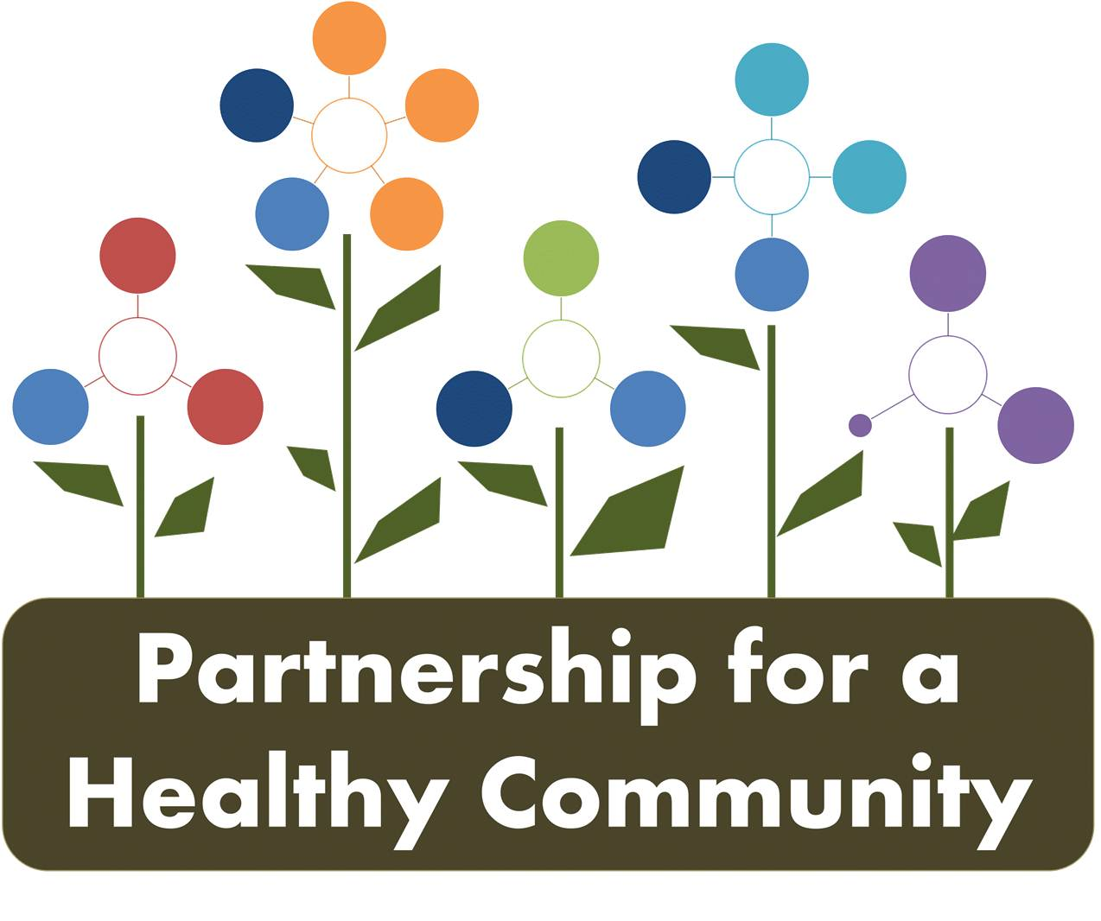
Healthy Eating Active Living (HEAL) Implementation Team
September 14, 2017
Attendees: Hillary Aggertt, Adrienne Southerland, Morgan Casey, Beth Beachy, Shanita Wallace, Julie Angle, Greg Eberle, Bill Shock, Glenna Mount, Margaret Cover, Kat Fowler, Denise Urycki, Michelle McCormick, Amy Fox

The meeting was called to order at 2:00 pm. The group was welcomed by Amy and Adrienne at the Tazewell County Health Department. Kaitlyn will be on Maternity leave until most likely the new year.
After brief discussion, the group broke into teams looking at concerns of adults and youth.
A recap of each area was given at the end of the meeting, 90 day implementation plans are in the process of being updated and are not attached to the minutes.

Youth Physical Activity- Will be working on increasing awareness of local school districts on opportunities to increase physical activity. A work team of Glenna, Greg, Morgan and Julie will be working on presentations and surveys to local schools, getting CATCH providers together to see what the status is of that program, and increasing opportunities for local open gyms and intramurals.

Youth Nutrition- The WIC implementation Team of Michelle and Beth will be working on creating partnerships with local grocers and creating visual displays with Fruit and Vegetable packages that are already weighed for certain amounts like a $5 bundle. This will help families with budgeting. Signage and consistent messages will also be recommended to grocers. Other ideas are Fruit and Vegetables being available for families to take home after WIC visits and helping families to create take home container gardens for their use next summer.

Adult Nutrition- Fresh Food Drive and Good Food Recovery donors and runners team is Sara, Betsy, Amy Denise, Shanita and Hillary- A meeting will take place on 8:30-9:30 am on October 10th for Peoria, Tazewell and Woodford County Health Departments and Solid Waste programs to work with the Good Food Recovery Program to learn more about the programs and to hopefully help with exposure to potential donors. A meeting to discuss the Fresh Food Drive program will take place October 12th at 1 p.m

Adult Physical Activity- The Trek Around Tazewell will be kicking off. Other partnerships would potentially include: Shazaam Events with Running Central, Park Districts, Silver Sneakers Programs, Adult Yoga series with Pekin and Peoria Park Districts and outreach to the YWCA and YMCA.

All areas are in the process of kicking off activities in a 90 day implementation plan.

Reminder:

A meeting for those who are wanting to work on the Fresh Food Drive for the Good Food Recovery project will meet at 1 p.m. on October 12th prior to our 2 p.m full HEAL meeting.
Next meeting will be October 12th at the Woodford County Health Department

