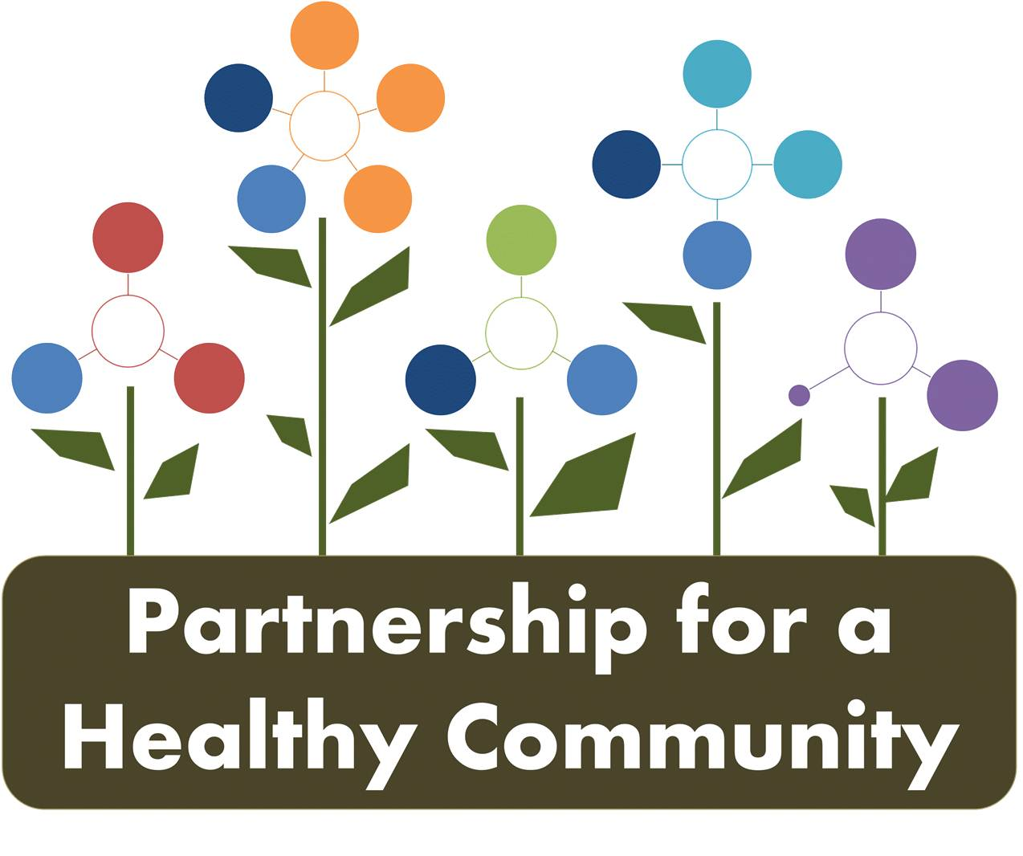
Healthy Eating Active Living (HEAL) Implementation Team
October 12 , 2017
Attendees: Shanita Wallace, Greg Eberle, Amy Fox, Andrea Ingwersen, Hillary Aggertt, Denise Uryicki, Jenna Smith, Julie Angle, Tracy Terlinde, Bill Schock, Rachel Benn, Glenna Mount

The meeting was called to order at 2:00 pm. The group was welcomed by Amy at the Woodford County Health Department. Kaitlyn will be on Maternity leave until most likely the new year. Adrienne will be leaving UnityPoint Pekin and will try to attend in the future for her new employer.
Members discussed initiatives that were currently happening.

Denise Urycki discussed the Good Food Recovery program and the need to find more contributors, recipients and food runners. The process is working but has primarily been fresh food. As we switch to the winter season prepared food will need to be a focus. Fresh Food Drives are being arranged for the new year. A drive would be for any organization to sponsor and the ask is for participants to bring in 10 pounds of fresh fruit of vegetables. The drives will help to support a research project being conducted by gitm and Bradley University at that will test if access to fresh fruits and vegetables will increase consumption. The project will focus initially on one food pantry in Metamora. All contributions beyond their need will be distributed to area food pantries and soup kitchens through the Chow Match software. The software allows for the right amount of food to be matched at the right time to recipients to prevent any spoilage. A flyer is attached to the minutes.

Greg Eberle discussed initiatives that the Hopedale Medical Complex is implementing. The Medical Complex will be writing Fresh Food Prescriptions for clients who are food insecure. Primarily focusing on the elderly. Food would be grown at the White Fence Farm facility with a partnership being built with local schools FFA and other clubs.

The Regional Fresh Food Council held a Fresh Food Summit at the end of September in Peoria. Approximately 60 people were in attendance. Senator Koehler sponsored this conversation about the need of our area. Additionally, the Regional Fresh Food Council is beginning to have County specific meetings. Woodford and Tazewell have had meetings that brought together local partners in the food system to talk about needs on a local level.

A discussion was held about the Trek Around Tazewell and the app that is being used by participants. The Benovate app is a wellness product that encourages healthy behaviors and tracks points and is linked to personal trackers. The app was pulled up and demonstrated. The offer of advertising initiatives through this growing wellness community was given.

Reminder:
Next meeting will be November 9th^{th} at the Peoria City/ County Health Department at 2 p.m

